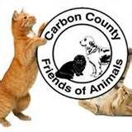
WISH LIST
WE ARE IN NEED OF THE FOLLOWING ITEMS

- Bleach | - Cat Litter Non-Clumping Please
- Purina Cat Food | - Purina Kitten Chow
- Baby Rice Cereal | - Gerbers Chicken Baby Food (No Veggie)
- Cat Nail Clippers | - Cat beds
- Paper Towels | - Hand Soap
- Latex Rubber Gloves (all sizes) | - Cleaning Products
- Plastic Spray Bottles | - Dish/Laundry detergent
- Heavy Black Garbage Bags | - Brooms/Mops
- Dust Pans/Brushes | - Copy Paper
- Black Sharpie Markers | - Post It Pads
- Index Cards in Blue, Pink and Yellow | - Pens
- Monetary donations | - Volunteers

