BENEFITS
CARBON COUNTY FRIENDS OF ANIMALS
$25
Per Person

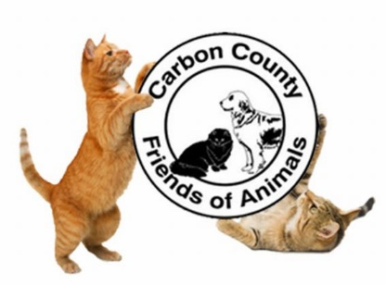
Bring your favorite non-alcoholic beverage!
Thank you for your continued support of CCFOA!

WHERE: CCFOA, 77 West 13th Street, Jim Thorpe PA 18229
WHEN: December 1, 2018
TIME: Noon – 3:00 PM

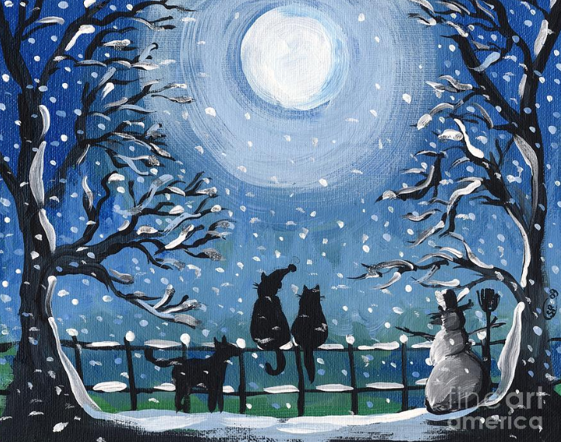
Payment due in advance.
Contact CCFOA at 570.325.9400 to reserve your seat.

