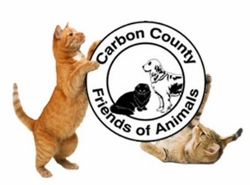
Carbon County Friends of Animals
Wish List

Cleaning Items

- Pine Sol & Fabuloso Floor Cleaner
- Lysol Cleaner, Spray and Wipes
- Bleach
- Hand Sanitizer
- Dish Soap
- Hand Soap
- Automatic Air Freshener Refill Cans
- he Laundry Detergent

Paper / Bedding Items

- Paper Towels
- Toilet Paper
- Pillow Cases
- Towels / Blankets

Cat Items

- Purina Cat & Kitten Chow
- Nail Clippers
- Wet Food
- Cat Litter (scoopable and non-scoopable)
- Cat Towers / Toys / Wands / etc
- Treats

Maintenance Items

- Mops
- Dust Pans
- Brooms
- Both Black & White Trash Bags

Stationary Items

- Index Cards (any color)
- Printing Paper
- Pens
- Highlighters
- Both AA & AAA Batteries

Miscellaneous Items

- Volunteers
- Monetary Donations

Medical Items

- Rubbing Alcohol
- Peroxide
- Gloves all sizes (powder-free / non-latex)
- Thermometers
- Heating Pads
- Q-tips (no plastic please)
- Vapor Rub (liquid)
- Compact Humidifiers

Please drop off all donations at the shelter facility between the hours of 9:00 AM – 5:00 PM. If you need the items picked up, please contact the shelter for assistance.
Carbon County Friends of Animals
77 W 13th St
Jim Thorpe, PA 18229
Phone: 570.325.9400

