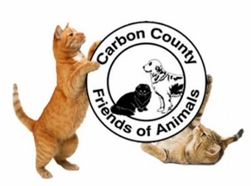
Carbon County Friends of Animals
Wish List

Cleaning Items
Fabuloso
Lysol Cleaner, Lysol Spray & Lysol Wipes
Bleach
Hand Sanitizer
Dish / Hand Soaps
Top Performance Disinfectant

Paper/Bedding Items
Paper Towels
Toilet Paper
Pillowcases
Towels / Small Blankets

Cat Items
Purina Cat & Kitten Chow
Nail Clippers
Wet Food – Friskies Preferred
Cat Litter (scoopable & non-scoopable)
Cat Towers / Toys / Wands, etc.
Treats
Kitten Bottles
KMR Milk

Maintenance Items
Mops
Dust Pans (stand up ones)
Brooms
Black & White Trash Bags

Stationary Items
Index Cards (any colors)
Printing Paper
Pens
Highlighters

Medical Items
Gloves (powder-free / non-latex)
any sizes
Thermometer
Heating Pads
Q-tips

ALSO:
*Fundraising Ideas
*Monetary Donations
*Volunteering

Please drop off all donations at the shelter facility between the hours of 9:00 AM – 5:00 PM. If you need the items picked up, please contact the shelter for assistance.
Carbon County Friends of Animals
77 W 13th St
Jim Thorpe, PA 18229
Phone: 570.325.9400

